The Listeners Press Gallery

Photos by Steven Pisano

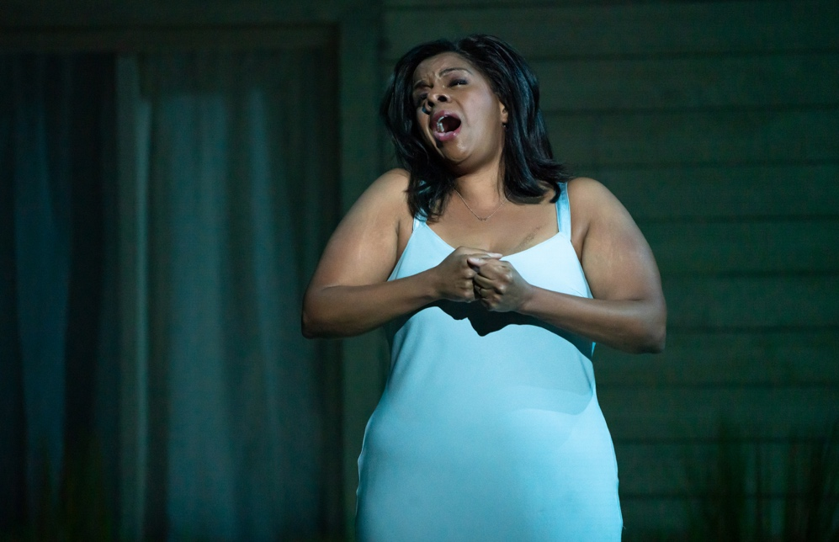 | 0031. Claire Devon (Nicole Heaston), passionately singing in Missy Mazzoli & Royce Vavrek’s The Listeners. Photo by Steven Pisano.
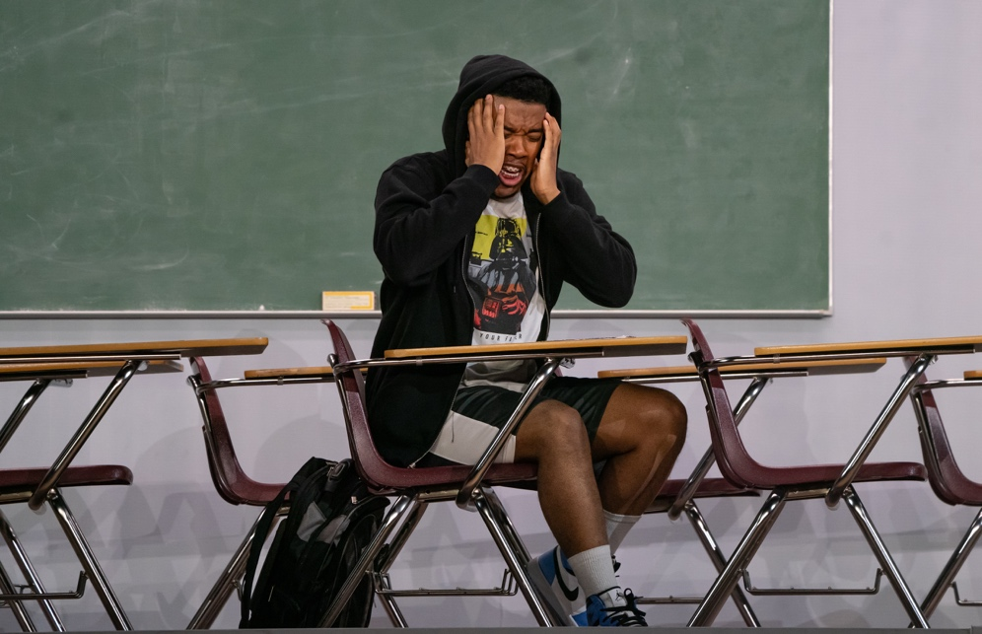 | 0624. Kyle Harris (Aaron Crouch), singing in Missy Mazzoli & Royce Vavrek’s The Listeners. Photo by Steven Pisano.
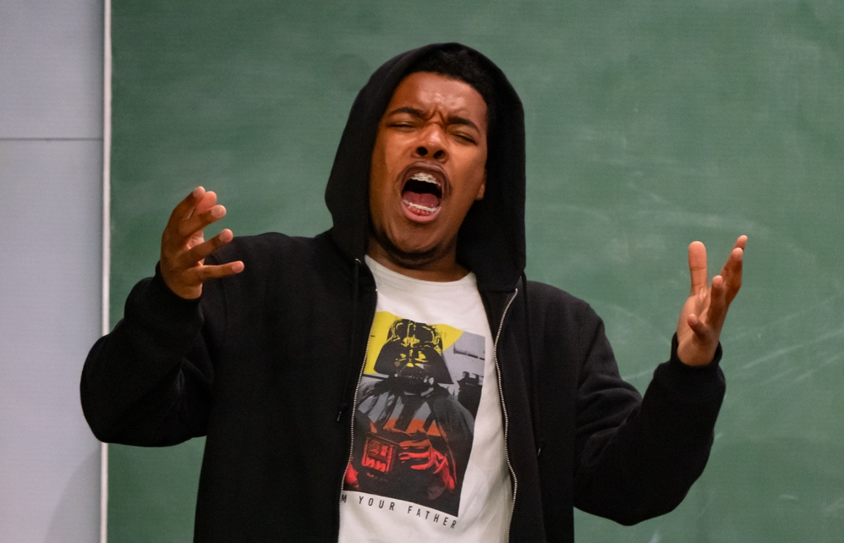 | 0665. Kyle Harris (Aaron Crouch), in Missy Mazzoli & Royce Vavrek’s The Listeners. Photo by Steven Pisano.
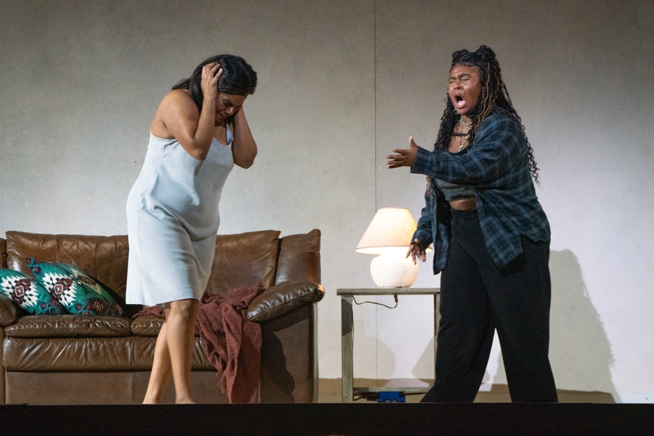 | 0888. Claire Devon (Nicole Heaston) and Ashley Devon (Lindsey Reynolds), singing in Missy Mazzoli & Royce Vavrek’s The Listeners. Photo by Steven Pisano.
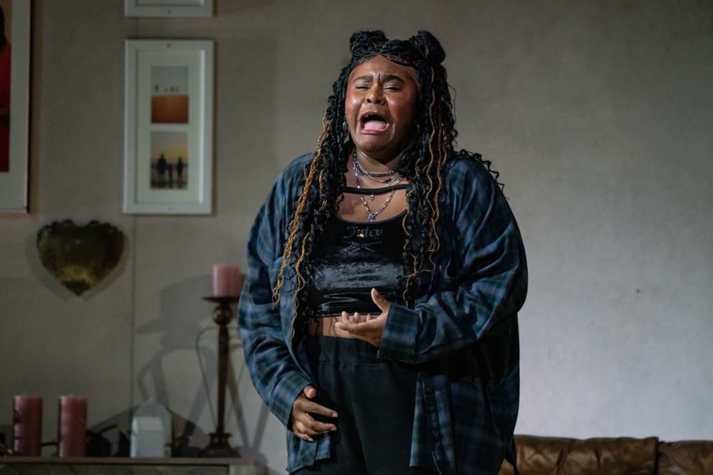 | 0900. Ashley Devon (Lindsey Reynolds), singing in Missy Mazzoli & Royce Vavrek’s The Listeners. Photo by Steven Pisano.
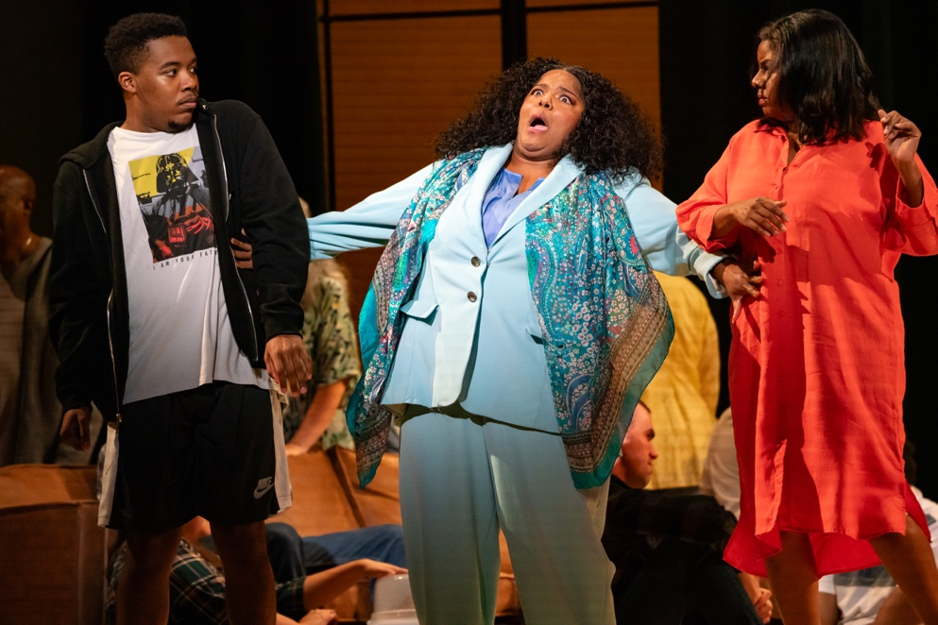 | 1137. Kyle Harris (Aaron Crouch), Claire Devon (Nicole Heaston) and Angela Rose (Rehanna Thelwell), in Missy Mazzoli & Royce Vavrek’s The Listeners. Photo by Steven Pisano.
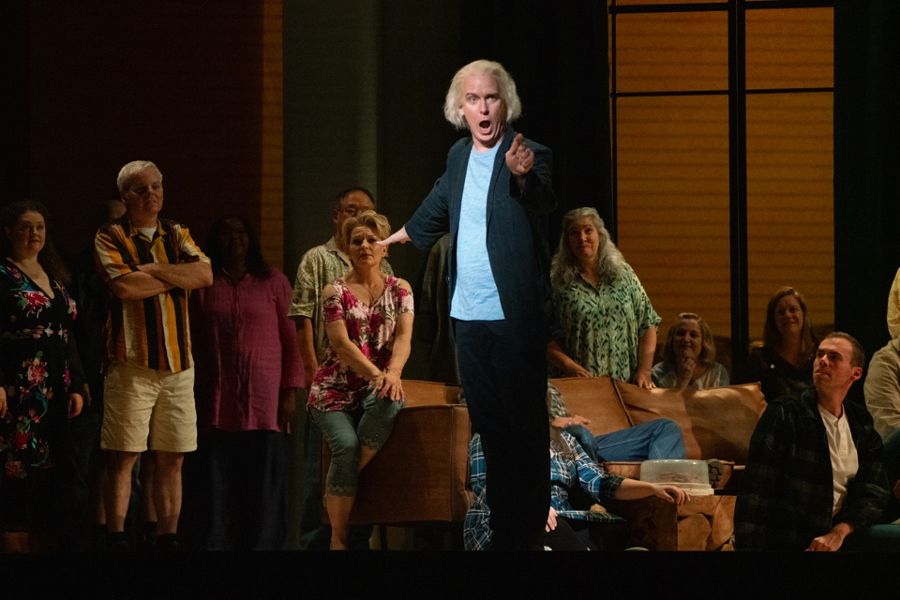 | 1376. Howard Bard (Kevin Burdette), in Missy Mazzoli & Royce Vavrek’s The Listeners. Photo by Steven Pisano.
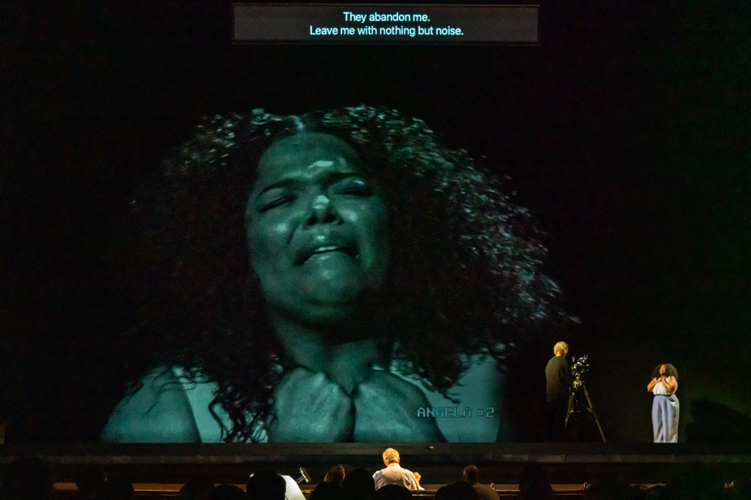 | 1743. Angela Rose (Rehanna Thelwell), in Missy Mazzoli & Royce Vavrek’s The Listeners. Photo by Steven Pisano.
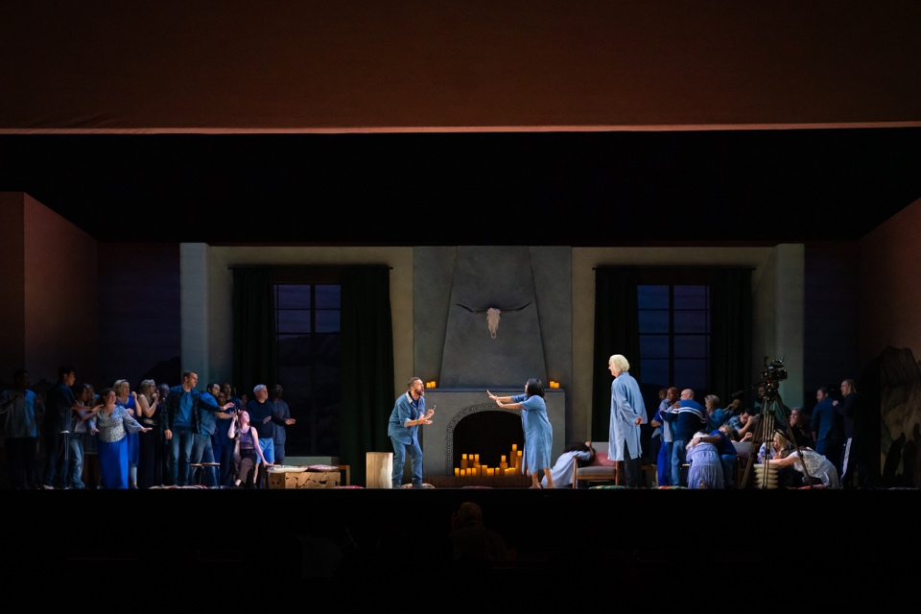 | 1899. A scene in Missy Mazzoli & Royce Vavrek’s The Listeners. Photo by Steven Pisano.
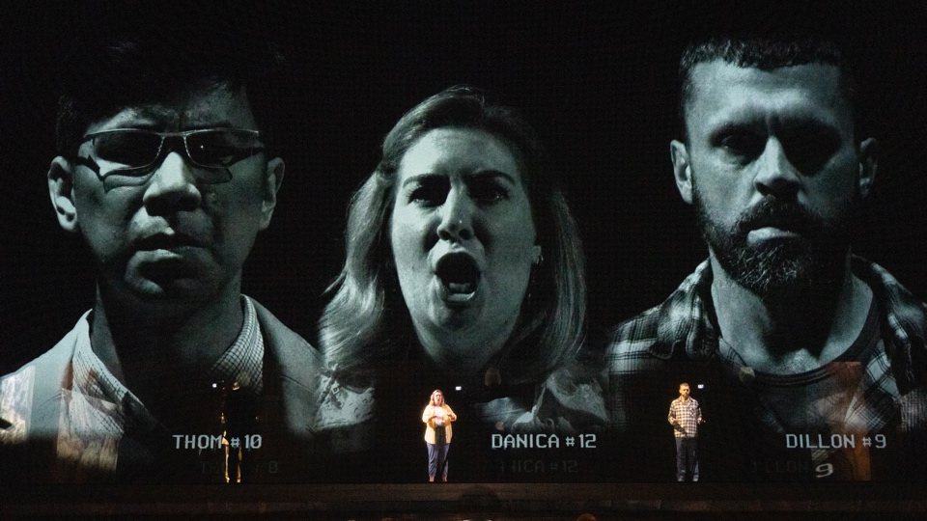 | 2245. Thom (Joseph Lim), Danica (Diane Newman) and Dillon (John Moore) in Missy Mazzoli & Royce Vavrek’s The Listeners. Photo by Steven Pisano.
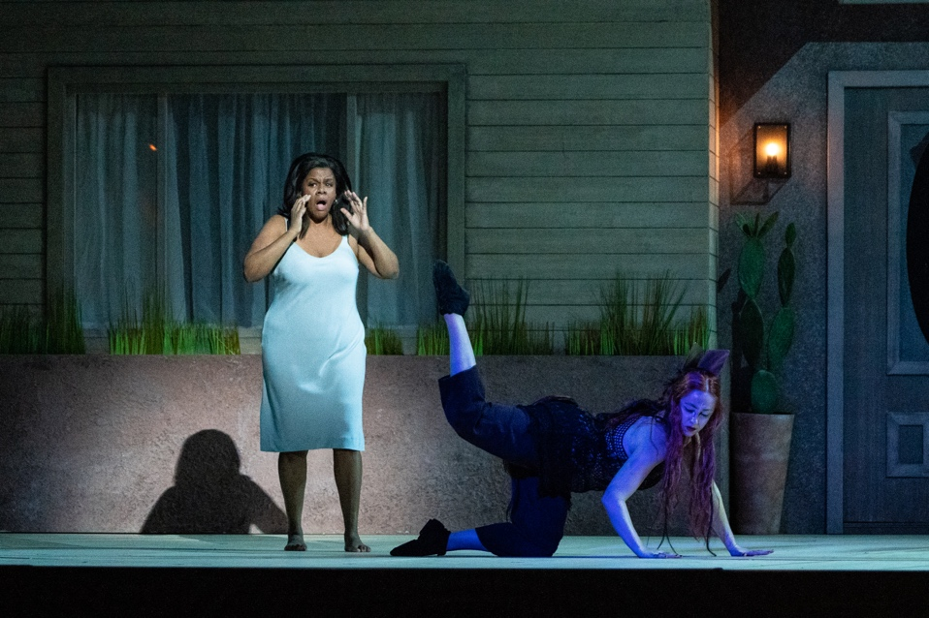 | 2280. Claire Devon (Nicole Heaston) and Coyote (Sydney Donovan), in Missy Mazzoli & Royce Vavrek’s The Listeners. Photo by Steven Pisano.
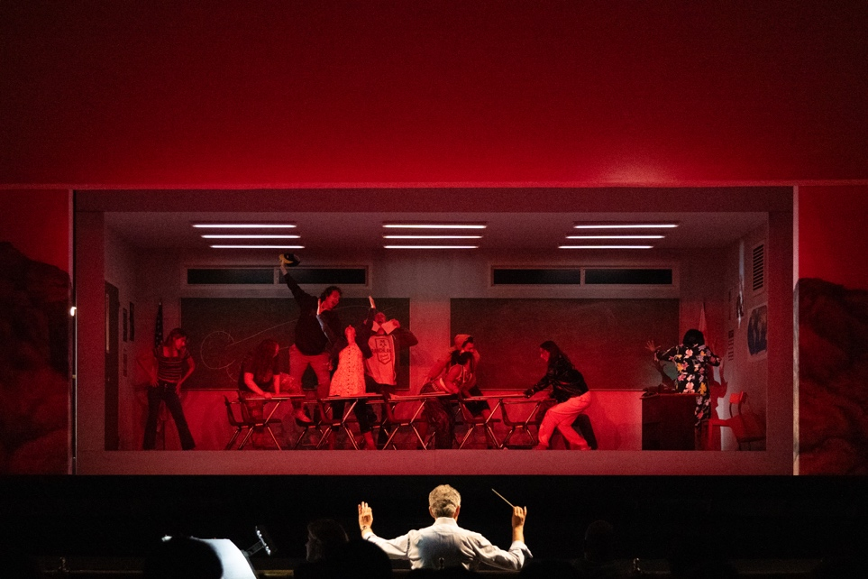 | 2296. A scene in Missy Mazzoli & Royce Vavrek’s The Listeners. Photo by Steven Pisano.
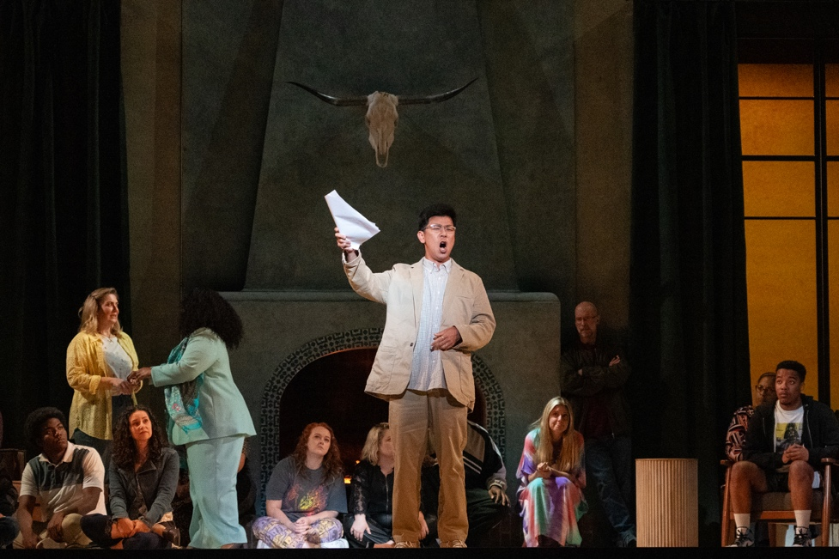 | 2542. Thom (Joseph Lim), in Missy Mazzoli & Royce Vavrek’s The Listeners. Photo by Steven Pisano.
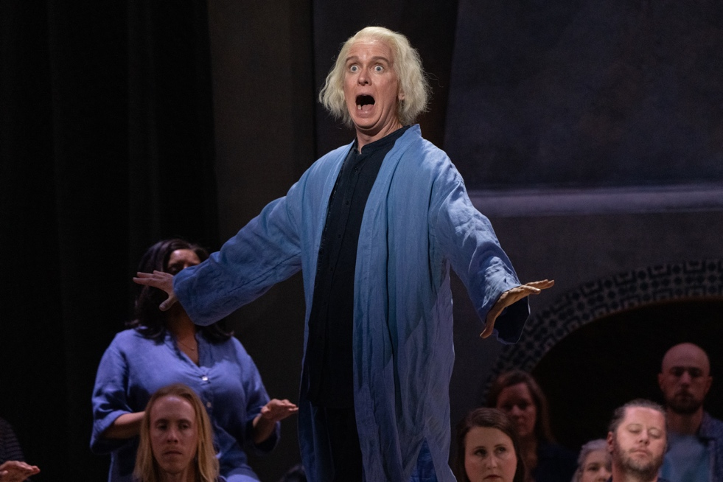 | 2769. Howard Bard (Kevin Burdette), in Missy Mazzoli & Royce Vavrek’s The Listeners. Photo by Steven Pisano.
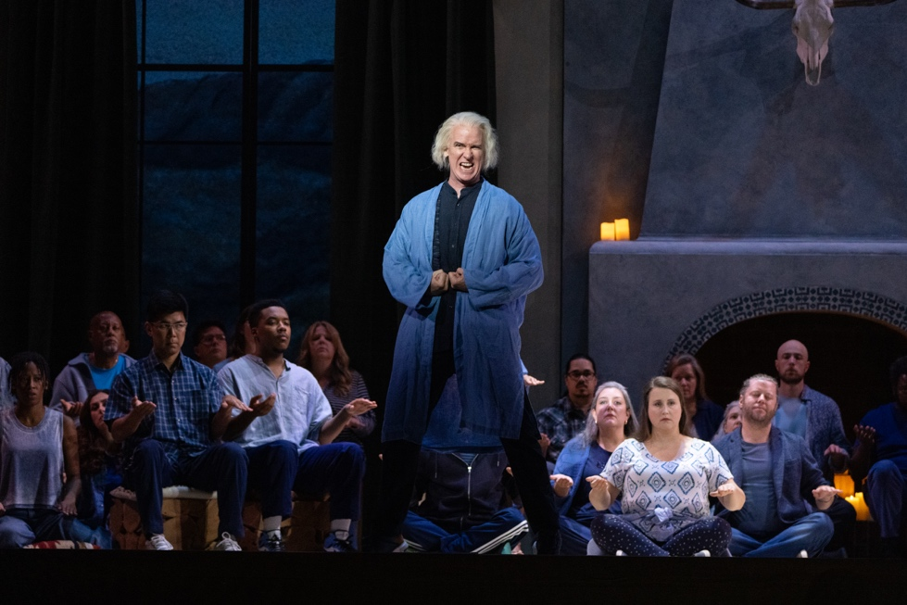 | 2834. Howard Bard (Kevin Burdette), in Missy Mazzoli & Royce Vavrek’s The Listeners. Photo by Steven Pisano.
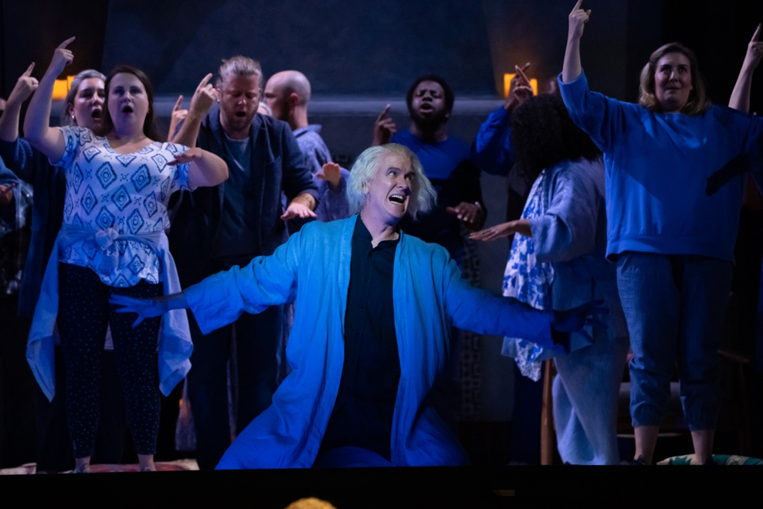 | 2943. Howard Bard (Kevin Burdette), in Missy Mazzoli & Royce Vavrek’s The Listeners. Photo by Steven Pisano.
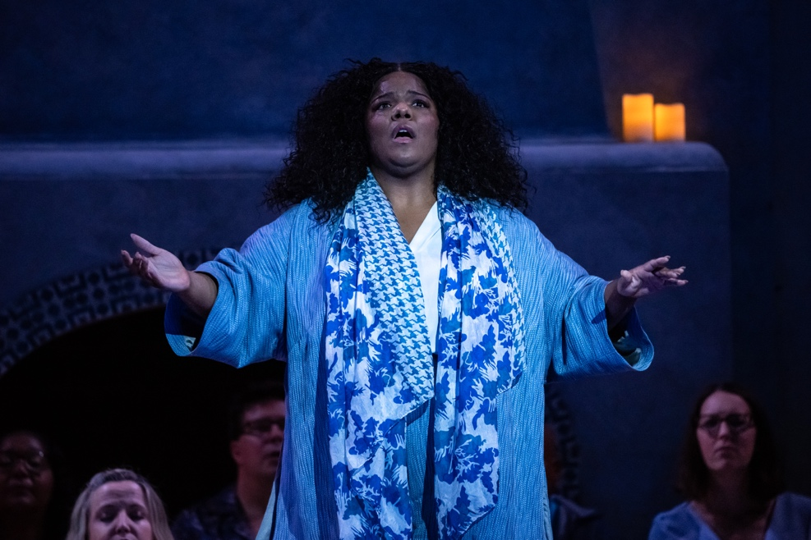 | 3114. Angela Rose (Rehanna Thelwell), in Missy Mazzoli & Royce Vavrek’s The Listeners. Photo by Steven Pisano.
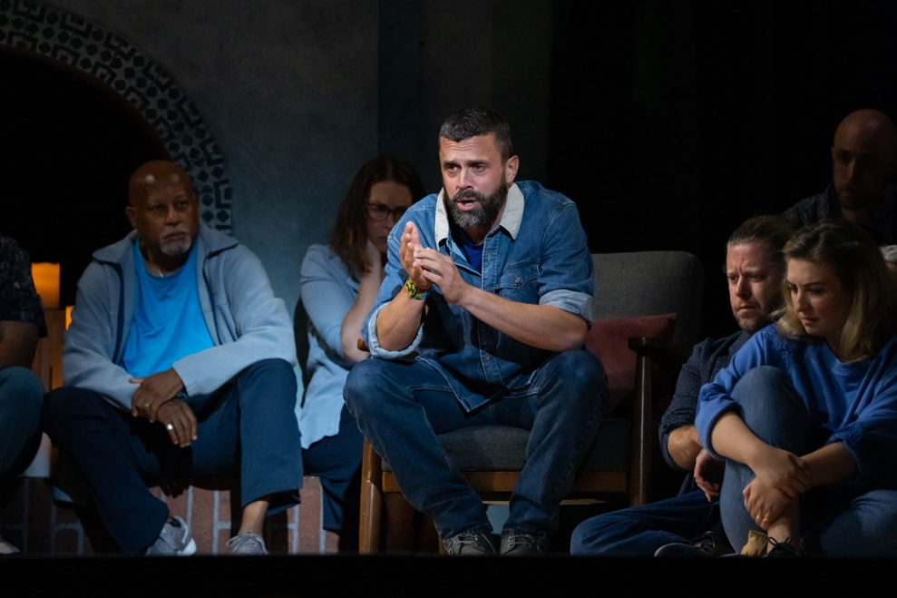 | 3253. Dillon (John Moore) in Missy Mazzoli & Royce Vavrek’s The Listeners. Photo by Steven Pisano.
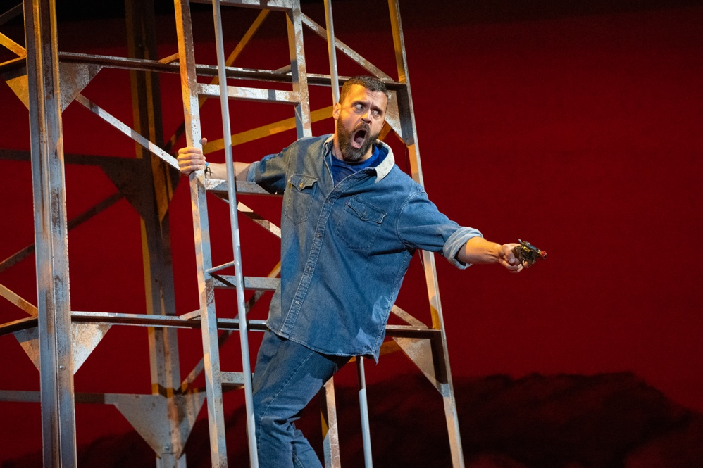 | 3887. Dillon (John Moore) in Missy Mazzoli & Royce Vavrek’s The Listeners. Photo by Steven Pisano.
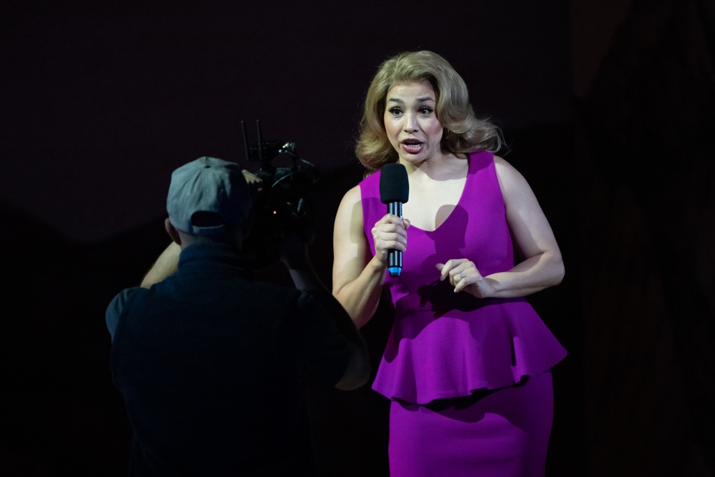 | 3913. Theresa Alvarez (Guadalupe Paz) in Missy Mazzoli & Royce Vavrek’s The Listeners. Photo by Steven Pisano.
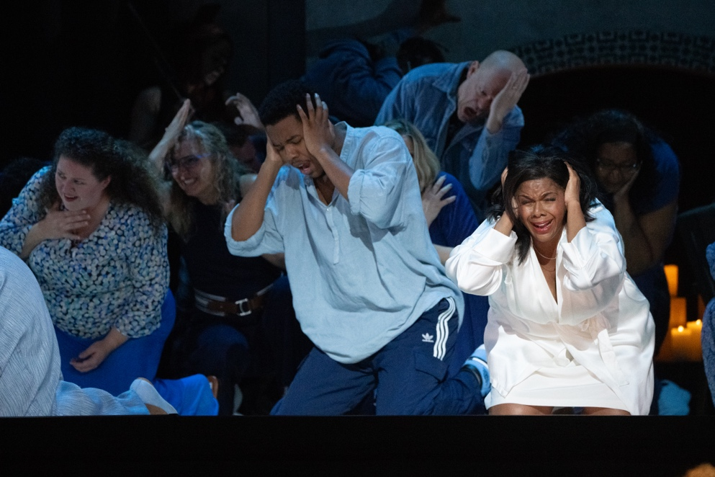 | 4337. A scene in Missy Mazzoli & Royce Vavrek’s The Listeners. Photo by Steven Pisano.
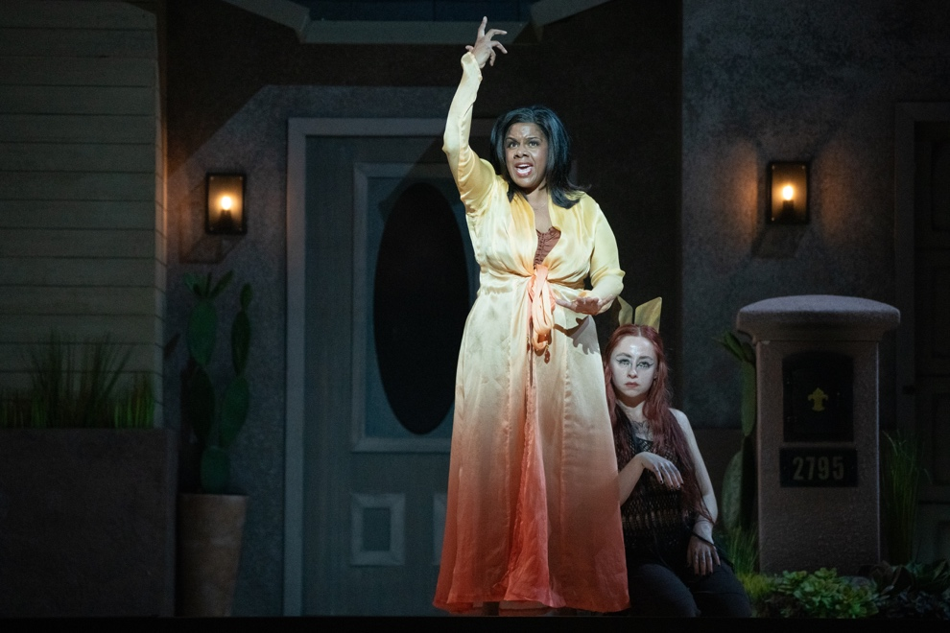 | 4698. Claire Devon (Nicole Heaston) and Coyote (Sydney Donovan), in Missy Mazzoli & Royce Vavrek’s The Listeners. Photo by Steven Pisano.

